APPLICATION FOR FINANCING HUMANITARIAN
PROJECT "ZATEYNIKI"

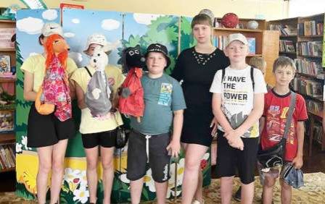

1. | Name of the project | "Zateiniki" (puppet theater at the children's reader service department of the Kirov Central Library)
2. | Name of company | State cultural institution "Network of libraries of the Kirov region"
з. | Physical and legal address of the organization, telephone, fax, e-mail | 213931, st. Kirova, 80A, Kirovsk, Mogilev region, Republic of Belarus State Institution “Network of Libraries of the Kirov District”, tel.802237 77 126, kultura_metod@mail.ru
4. | Information about the organization | The state cultural institution “Network of Libraries of the Kirov District” is a non-profit organization that is the information and sociocultural center of the region, providing the population with information resources. The mission of the library is to provide each user with high-quality and effective access to any information resources that contribute to their educational, creative and professional activities, the experience and ideas of others, to promote cultural education, citizens, and to be a conductor of culture.
5. | Head of the organization | Marina Vladimirovna Tsvetkova, director of the State Institution "Network of Libraries of the Kirov District", tel.802237 77 126,
6. | Project manager | Nikolaenko Elena Nikolaevna, head of the library marketing department, 802237 77 127
7. | Previous assistance received from other foreign sources | No
8. | Required amount | 7 700 (in US dollars)
9. | Co-financing | 770 (in US dollars)
10. | Project duration | Constantly
11. | Objective of the project | Drawing attention to the creative abilities of children and adolescents, inclusive education of children with special needs together with their peers through puppet theater. Ensuring the participation of children and adults in puppet shows. The puppet theater will become a means of spiritual and moral education of children and the formation of cultural values ​​in them. This will help develop intellectual and personal qualities.  During the puppet show, children will learn to understand how to distinguish between good and under what masks evil can hide. Puppet characters evoke a vivid emotional response in a child’s soul; they show examples of friendship, responsiveness, kindness, courage, and hard work. To create comfortable conditions for holding events, it is necessary to purchase:  - sound reinforcement equipment (speakers, microphone) – $1200;  - dolls (15 units) – $300;  - floor and table screens – $300;  - laptop 1 pc. – $1200;  - transportation costs – $500;  - ottomans 8 pcs. – $2700;  - children's racks 5 units. – $1500
12. | Project objectives | To interest the population in puppet theater as an art form. Introduce children to art, reading culture, Belarusian culture and traditions. Learn the basics of acting. Teach the basics of creating and running a home puppet theater. Invite readers to visit the library
13. | Detailed description of activities within the project in accordance with the assigned tasks | The project will be implemented jointly with general educational institutions in Kirovsk. Puppet theater performances are planned to be organized in kindergartens and schools of the district, open areas of the district, State Educational Institution “Preschool Child Development Center of the City of Kirovsk”, family-type houses, etc. This project will contribute to the development of the puppet theater created at the library, maintaining sustainable interest in art, literature, and theater; attract the attention of the younger generation to the preservation of Belarusian folk culture. Target group: children, adolescents, their parents and legal representatives, youth (10-16 years old), young families under 35 years old, families with children, teachers, residents of the Kirov region
14. | Project justification | The relevance of this project lies in the active approach to the upbringing, education and development of mainly children and the population as a whole through the means of puppet theater; showing performances based on classical and modern works by authors, as well as scripts by library staff, based on the traditions and rituals of Belarus. After talking with residents of the city of Kirovsk, we decided to create a comfortable place for holding puppet shows, where one could relax and hold cultural events. Puppet theater is a wonderful art form that has survived to this day, which has always pleased and will continue to delight children, despite all digital technologies. In the library he will help build a bridge between the book and the child, and he will always be a good assistant for us in working and communicating with children
15. | Activities after the end of the project | The created space will facilitate joint events with other institutions. Will attract the attention of other cities
16. | Project budget | 7700 (in US dollars)

Territory of the premises for creating a future project

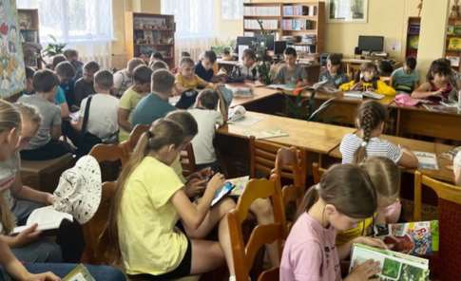

Territory of the premises for the future project

